**Exercise 10.**

LabView objects in Multisim

Table of Contents

List of Figures 1

Abstract 2

Part 1: Using LabView Signal Generator and Signal Analyzer objects 3

Part 2: Inserting objects created in LabView 11

Part 3: Homework 14

# List of Figures

Figure 1 Setting the parameters of the Signal Generator object 3

Figure 2 LPF Configuration. 4

Figure 3 Generator configuration 4

Figure 4 Time Domain Output 5

Figure 5 Output 5

Figure 6 Desired output for square wave 1kHz. 6

Figure 7 Bandpass Sine Input and Output Waveform 7

Figure 8 Output Auto Power Spectrum. 8

Figure 9 Triangle output time domain. 9

Figure 10 triangular signal almost becoming a sine wave 9

Figure 11 power spectrum output 10

Figure 12 Square wave output time domain. 10

Figure 13 auto power spectrum 11

Figure 14 Elevator Circuit Design 12

Figure 15 base floor. 12

Figure 16 2nd floor. 13

Figure 17 1st floor. 13

Figure 18 Simple test circuit 14

Figure 19 LPF with microphone and speakers. 14

# Abstract

The aims of this laboratory exercise were to learn the basics of using NI Multisim 10 simulation program:

* use the LabView applications in Multisim,

# Part 1: Using LabView Signal Generator and Signal Analyzer objects

For this part of the laboratory we will use LabView objects. Such as a Signal Generator, Analyzer, and an included elevator.lib file.

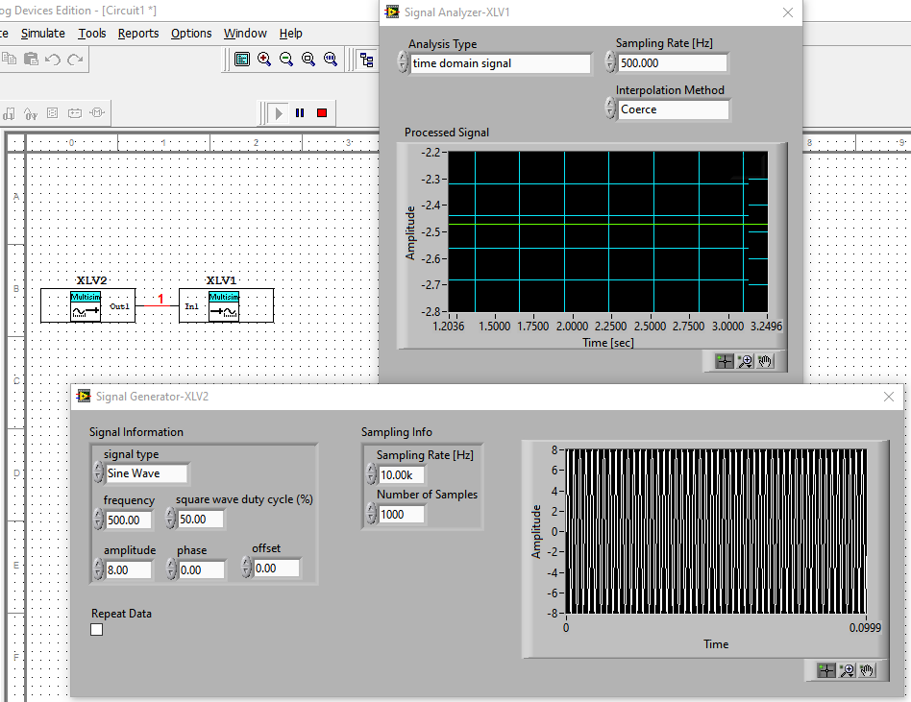

Figure 1 Setting the parameters of the Signal Generator object

For this part of the exercise we will design a low pass filter, band pass filter for audio frequencies 20Hz to 20kHz, freely we select the type of filter using the application wizard function built into Multisim.

In the below please see the low pass filter example.

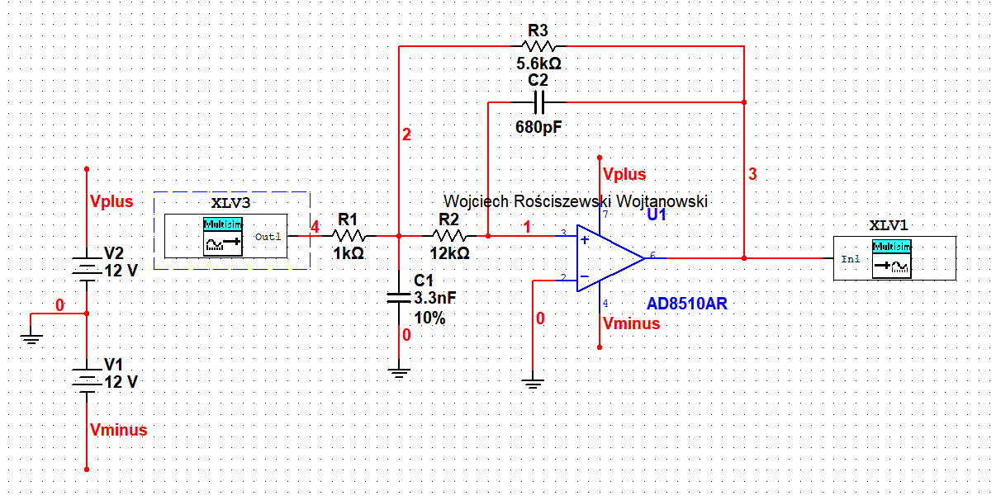

Figure 2 LPF Configuration.

As seen in the above the circuit presented is an LPF, with use of the AD8510AR. I’ve connected the generator as well as the analyzer and we should see the output result of the auto power spectrum. Here we should see the harmonics of the filter, so for example if we generate a signal of 1kHz our first harmonic should be the 1kHz generated, then we should have a decrease that the signal is filtering. So higher harmonics are very small amplitude.

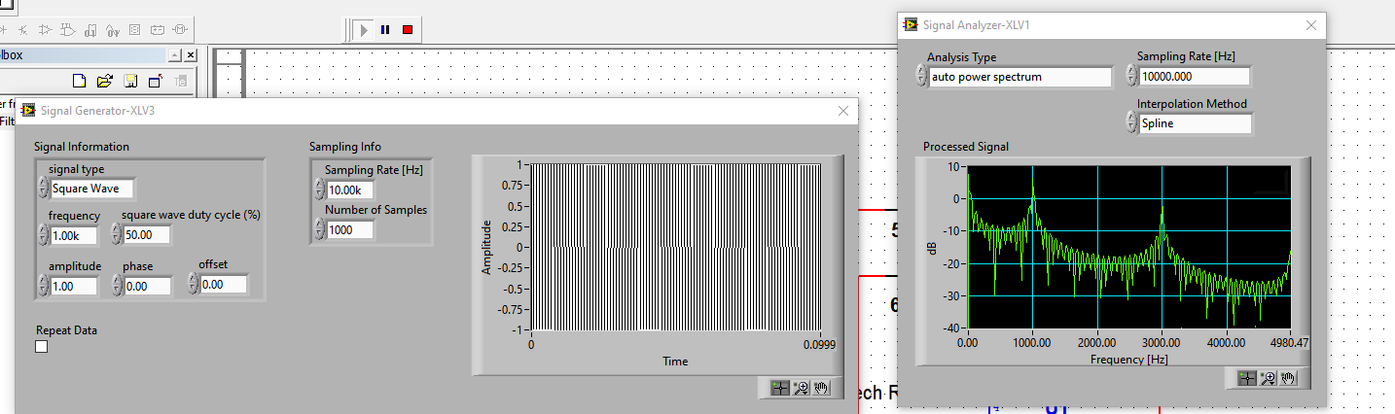

Figure Generator configuration

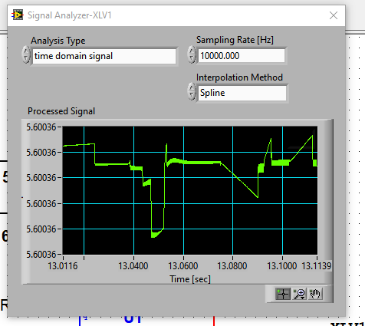

Figure 4 Time Domain Output

Time domain output is strange of course we cannot achieve in real life a perfect frequency response however in this simulation. I understand that we have a very steep transition between the passband and stop band and that this requires a quire long pulse to see this, so I presume that we can’t really see this come out of the filter.



Figure 5 Output

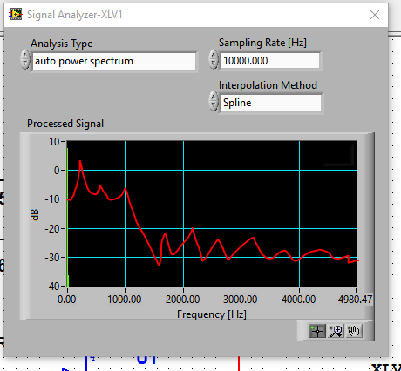

Figure 6 Desired output for square wave 1kHz.

So as we can see the filter isn’t working correctly, here we see that something is happening however we should see something as visible in the figure above, the filter should work and all of this should be visible however here the signal disappears and changes into a single line. For all filters, for all signal frequencies. Below please see my conclusion.

To conclude, throughout the experiment this has not worked correctly I have tried many different configurations but I’m afraid something is either wrong with my computer configuration or my multisim program, best bet is that it’s the version of multisim that is at fault as many other of my colleagues during the experiment has experiences similar behavior. Problem is I cannot show correct results however I am able to draw in a program what we should have been able to see on the Signal Analyzer window, since we know what to expect – to remove higher frequencies from our signal. If we choose other signals so not sinus but sawtooth we will achieve similar effects the waveform presented in the signal analyser will changer however the effects will still be the same as we will still see the first harmonic being 1kHz in case for example sawtooth signal.

I have done the same to the bandpass filter please see in the below

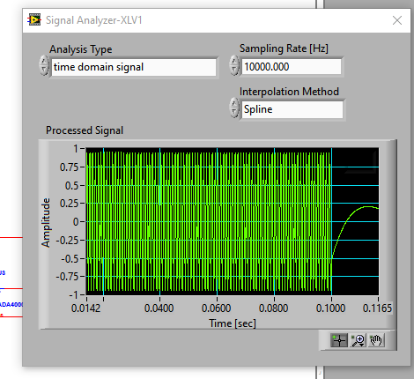

Figure 7 Bandpass Sine Input and Output Waveform

What we should see is the high pass filter to pass through all frequencies and the low pass filters should pass all of the lower frequencies and we in a way generate this sandwich like shape on our filter. However here we constantly give a 1kHz input signal therefore we should see that the signal is constantly being controlled however here out simulation varies its results which in my perspective is quite strange. Below please see the power spectrum achieved.

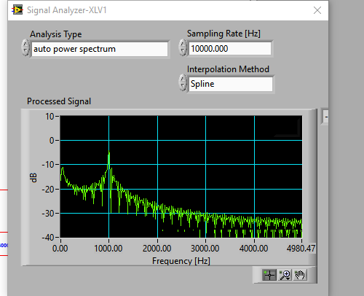

Figure 8 Output Auto Power Spectrum.

Here we see the output power spectrum of our system, what is visible is that the filter works very strange as it has a peak at the start of the scale, then it cancels out that frequency and then it enables the 1kHz harmonic to pass and cancels the rest, somewhat it does work as it does trap the frequencies and passes on the lowers yes. However, the start of our spectrum seems to be indifferent, I assume that this is a software issue that is causing this scenario.

Lets try for triangle input wave this time at 10kHz.

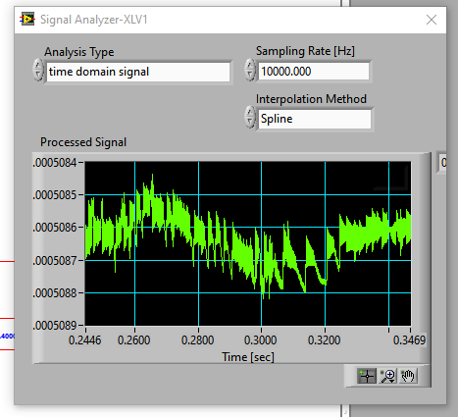

Figure 9 Triangle output time domain.

We see that the filter is working as per design, the waveform is in fact being filtered somewhat, however over time we should see the waves change into a sinusoidal shape almost due to the bandpass capabilities, and it almost does this however again I am unsure of why I receive such strange results, I assumed that the filter would actively reduce and flatten the signal but here I see a lot of strange spikes.

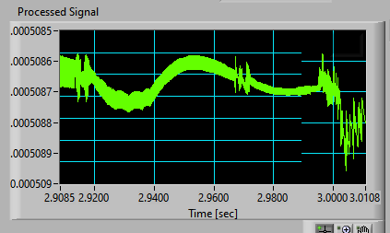

Figure 10 triangular signal almost becoming a sine wave

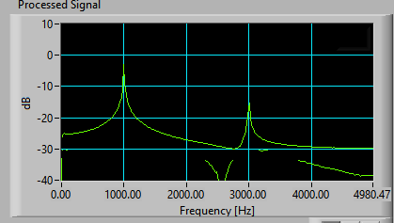

Figure 11 power spectrum output

We see that the wave filtered is in fact filtered but also strangely attenuated.

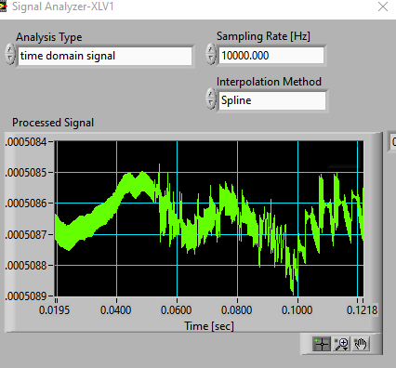

Figure 12 Square wave output time domain.

Here we see the square wave characteristic passed through the passband filter. We see that somewhat the signal is filtered however not ideally, since we have these steep lines that almost look like noise in the signal. The circuit is built correctly as for direct inputs it generates a correct output.

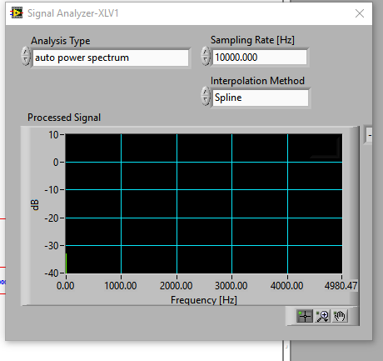

Figure 13 auto power spectrum

For the output of the square wave power spectrum we can only see some green line at the bottom of the left screen. I have restarted the simulation and even used a completely new filter schema from a different research source which demonstrated a very close effect. Therefore, I assume there is some error with the software. To conclude, the simulation was not successful, I presume that as mentioned during our laboratory exercises this can be caused by the multisim error, however from the theoretical perspective I can imagine myself what the output would be ideally. Of course, for some filters we cannot match ideal real case scenarios if we build such filter physically as this is generally limited to the costs spent on materials and order of the filter. The higher the order the better the filter and more accurate it is however the more expensive it is, of course in simulation we save on money as we only rely on a computer program to perform calculations, for free.

# Part 2: Inserting objects created in LabView

For this part of the exercise we will insert a provided object, in this case an elevator. We must use the sample file named Elevator_Display.llb that was created using LabView, we insert the file into the Circuit Design Suite folder in IVinstruments. In LavView instrument tab we will see the Elevator Display Object, when available click on it. For the purpose of this exercise we have ran the simulation

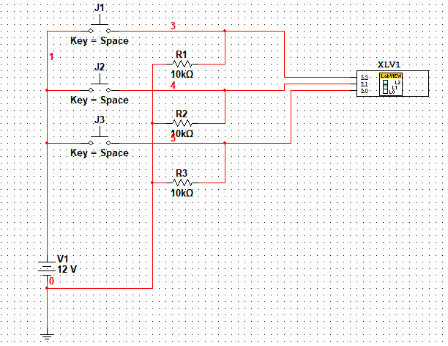

Figure 14 Elevator Circuit Design

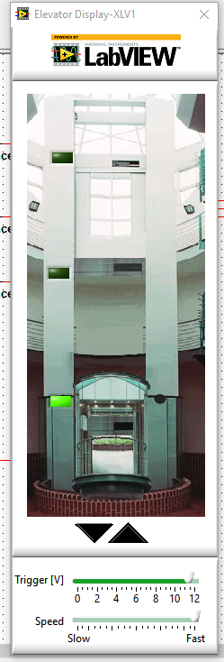

Figure base floor.

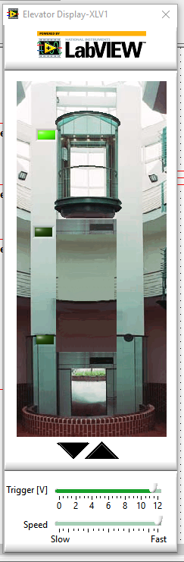

Figure 2nd floor.

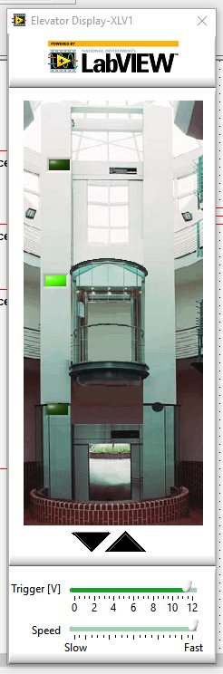

Figure 17 1st floor.

Conclusion using the simple elevator design system we were able to manipulate the object to travel, or for the elevator to change floors. We also have speed options to control the speed of the elevator as well as the trigger amount. Very interesting exercise.

# Part 3: Homework

For this part of the exercise we must create a simple circuit with a microphone and speaker objects designed in Multisim, I will record and replay my voice using multisim.

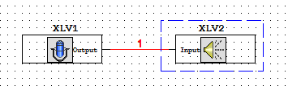

Figure 18 Simple test circuit

After recording my voice I have played back and heard myself speak, the change of sample frequency really does affect the output result in the speakers.

For the next part of the system we will remake the circuit and add a filter for audio frequencies, we will test the circuit with the recorded voice.

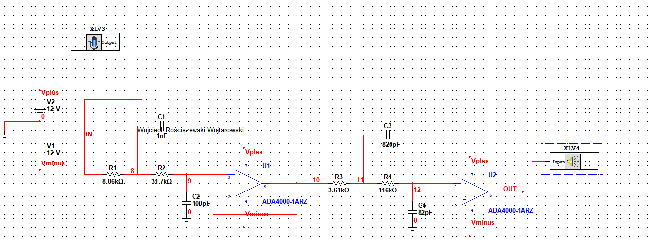

Figure 19 LPF with microphone and speakers.

Conclusion: I heard that my voice is less polluted with signal noise generated near me, very interesting activity. This is a very similar exercise as to the one we did in LTSpice software with out analog filter design where we investigated the behavior and characteristic change of different sample sounds according to our filters, this simply shows that we can recreate this similar exercise on multisim software.